**DEPARTMENT OF ORAL AND MAXILLOFACIAL SURGERY**

**TAGORE DENTAL COLLEGE AND HOSPITAL**

**MELAKOTTAIYUR POST, RATHINAMANGALAM**

**CHENNAI – 600127**

**PH: 044 – 3010 2222, EXTN: 228 / 230**

**EMAIL ID:** [maxfacs@tagoredch.in](mailto:maxfacs@tagoredch.in)

**PROF.M.MALA DR.C.J.VENKATAKRISHNAN**

**CHAIRPERSON PRINCIPAL**

**ORGANIZING COMMITTEE:**

**PROF.DR.S.JIMSON**

DR.B.LOKESH

DR.B.ANANDH

DR.BALAKRISHNA

DR.MEERAN SHARIF

DR.ISRAEL NATHANAEL

DR.JONES JAYABALAN

**ORGANIZER:**

**Research committee**

**&**

**Department of Oral & Maxillofacial Surgery**

Tagore Dental College & Hospital

Date:**OCTOBER 8TH 2021**

**LEARNING OUTCOME:**

To acquire detailed knowledge on Biostatistics & Research methodology .

**VENUE:** Conducted online through official **GOOGLE MEET** application**.**

**GUEST SPEAKERS:**

**1. Dr.Saravanakumar.V**

Scientist –B

ICMR –NIE

**TOPICS COVERED:**

1. Biostatistics

2. Research methodology

The program started with the welcome note by the Organizing chairman, Prof.Dr.S.Jimson and a short introductory speech by Dr.Venkatakrishnan. The lecture session started by 1pm. It was a detailed and very informative lecture on “biostatistics & research methodology”. A discussion session and question and answer session was followed by the lecture. The program ended with the vote of thanks by Dr.Israel Nathanael.

**PROGRAM FEEDBACK:**

The program was attended by 53 participants. The program received a Excellent feedback from the participants.

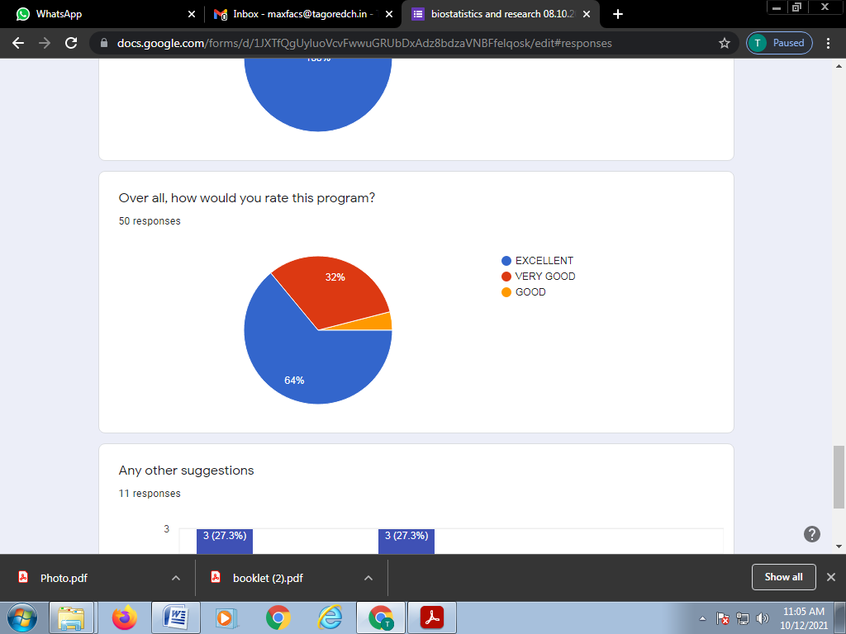

**PICTURES:**

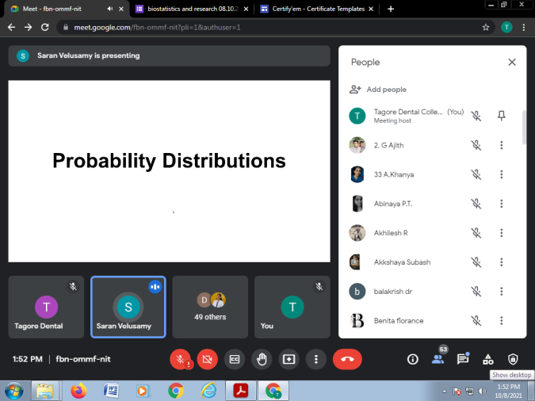

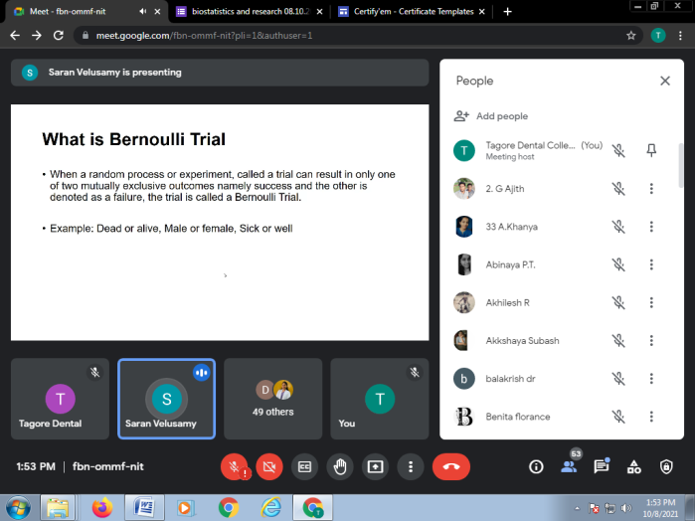

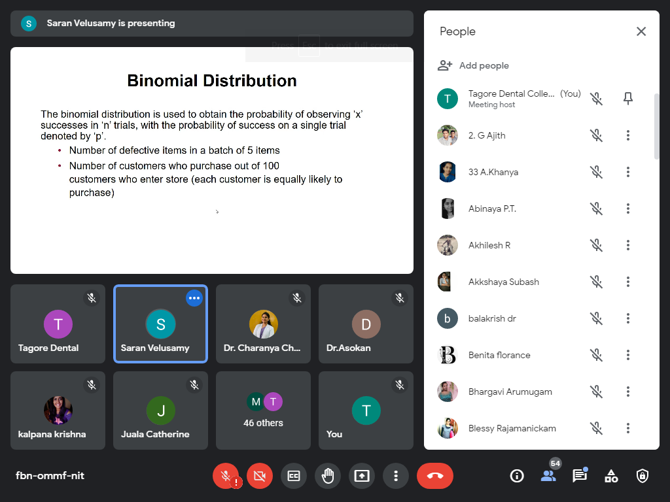

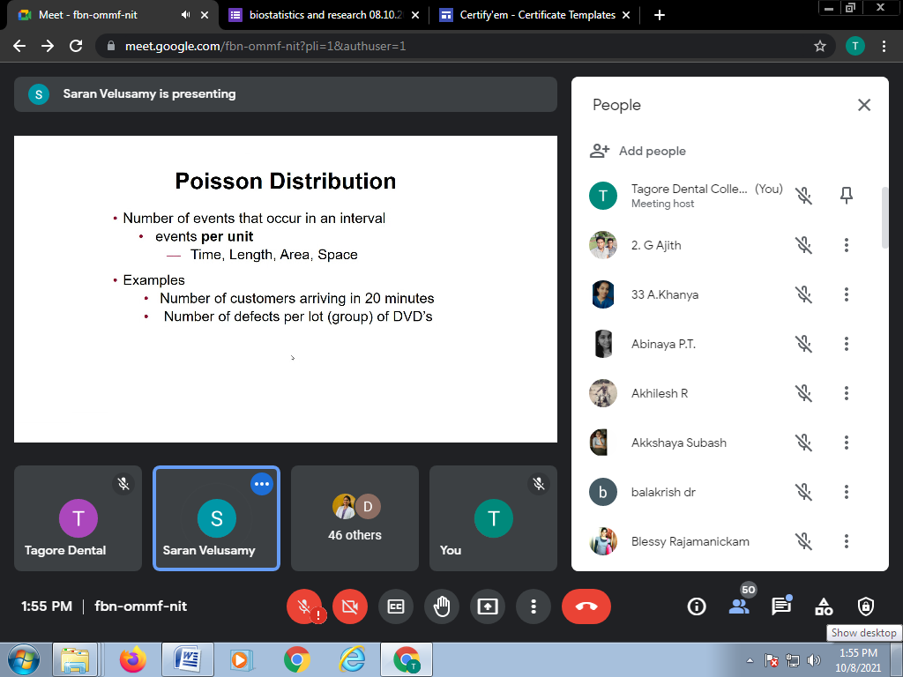

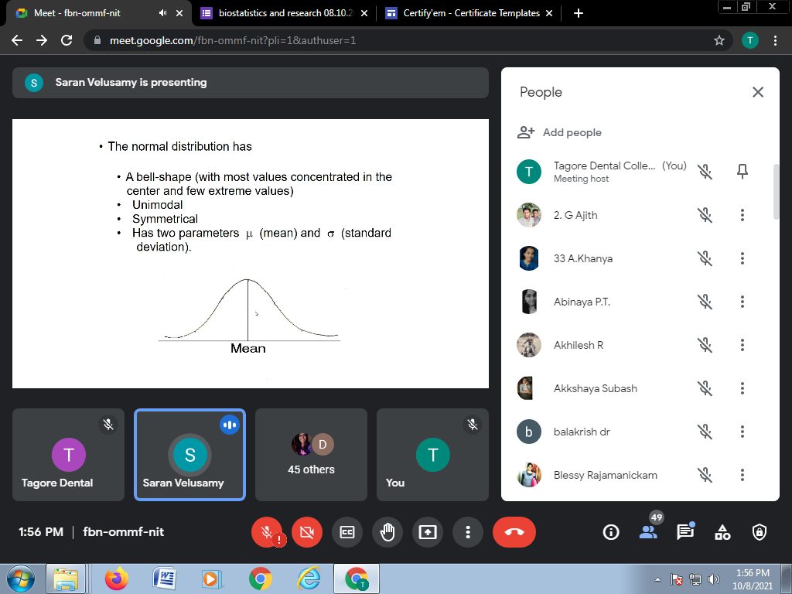

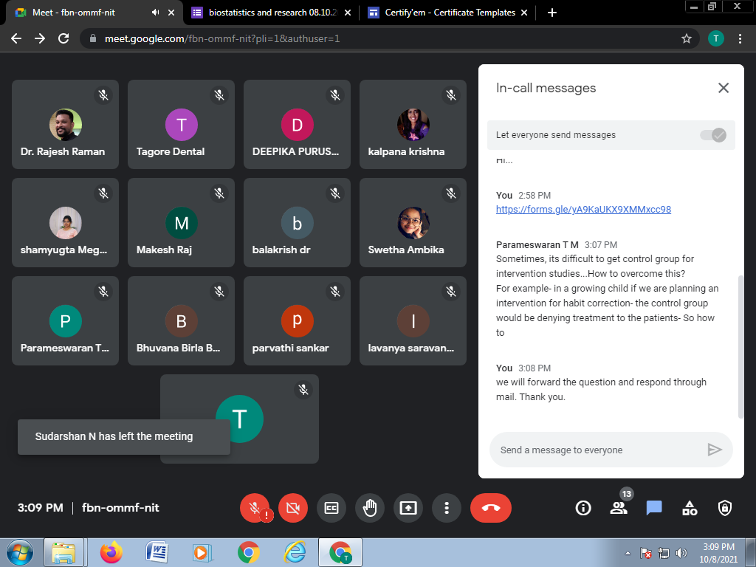

ATTENDANCE: **BIOSTATISTICS & RESEARCH METHODOLOGY**- DR.SARAVANAKUMAR.V 8-10-2021

1. S.AKKSHAYA
2. KALPANA HARI KRISHNAN
3. KHANYA A
4. SANJAY KARTHIK K
5. DR.PRIYADARSHNI .R
6. DEEPIKA. R
7. BHARGAVI
8. AJITH G
9. DR.PARTHASARADHI.T
10. BHUVANESWARI B
11. M.NIVETHA
12. NAVAPRIYA
13. DINAKAR R
14. POORANI.V
15. KEETHANA R
16. NITHYASHRI P
17. BLESSY R
18. HANISHA SELVAN
19. AKHILESHWARAN.R
20. VIGNESH VIKRAM
21. KEERTHI P
22. JUALA CATHERINE
23. ABINAYA
24. THIRUNAVUKKARASU
25. AVINASH.G
26. SUBIKSHA RAVI
27. M.GEETHANJALI
28. SUDARSHAN N
29. NIVEDHA N
30. MOHAN RAJ
31. P.KAVITHA
32. KIRTHIEKA.S
33. SUHASINI
34. THARUN KUMAR B
35. HARSHITHA BALAJI
36. P.HARSHA VARDHAN
37. NANDHINI.S
38. KRISHANGA SRIVASTAVA
39. ISWARYA K
40. KIRUTHIKA
41. KARTHIK K
42. KABILAN
43. V. SWETHA
44. N.DEVA KUMAR
45. DR PARAMESWARAN T M
46. SHANTHINI PRIYA A
47. DR.PARVATHI S
48. DR.LAVANYA
49. BALAKRISHNA R N
50. N.S.YAZHINI
51. FELCY A
52. LOGESH.R
53. ISRAEL NATHANAEL